|  | **ICT ACADEMY OF KERALA**  **Group members:**  **1.Akhil.k**  **2.Treesa**  **3.Priyala**  **4.Karthika**  **5.Divya** |
| --- | --- |

**Performance Test Report**

**12/10/2022**

**Performance Test Report ICT ACADEMY OF KERALA**

**ICT ACADEMY OF KERALA**

| **Name** | **Role / Designation** | **Date** | **Signature** |
| --- | --- | --- | --- |
| AKHIL |  |  |  |
| KARTHIKA |  |  |  |
| DIVYA |  |  |  |
| TREESA |  |  |  |
| PRIYALA |  |  |  |
|  |  |  |  |
|  |  |  |  |

**Record of Changes**

| **Version**  **Number** | **Date** | **Author/Owner** | **Description of Change** |
| --- | --- | --- | --- |
|  |  |  |  |
|  |  |  |  |
|  |  |  |  |
|  |  |  |  |
|  |  |  |  |
|  |  |  |  |
|  |  |  |  |
|  |  |  |  |
|  |  |  |  |
|  |  |  |  |
|  |  |  |  |
|  |  |  |  |

# 1.Executive Summary

Performance Testing is **the process of analyzing the quality and capability of a product**. It is a testing method performed to determine the system performance in terms of speed, reliability and stability under varying workload. Performance testing is also known as Perf Testing.

## 1.1 Overview: Project Background and Scope

The performance testing ensure the system performance in terms of speed, reliability and stability under varying workload for **ICT ACADEMY OF KERALA** Application Architecture

ICTAK Website is a responsive website for ICT Academy of Kerala. Which is used as a main platform for interacting with participants and displaying ICTAK courses' details and also it allows the admin to perform certain operations and get the registration details of the participants.

## 2. Application Architecture

## 2.1 Overview: System Architecture

Launching ICTAK website lead to the home page of the website which contain the basic informations about the academy and the navigation menu bar which will take to each pages such as about us, courses(dropdown), membership(dropdown), events(dropdown), contact us and login button for the admin.

Each course has a registration form, a confirmation mail should be sent to their respective email-id. And admin should be able to get all the registration details in his/her dashboard and can download it as an Excel file.

Membership page includes separate application forms for Academic and Corporate with custom validations and once filled they receive a confirmation mail. And admin should be able to get all the registration details in his/her dashboard and can download it as an Excel file.

Contact Us page includes the physical address and contact details of ICTAK with a contact us form with custom validations and users can subscribe for the fast access for the new updates.

## 

## 2.2 Detailed information on tool used in performance testing

**Apache JMeter**

The Apache JMeter™ application is open source software, a 100% pure Java application designed to load test functional behavior and measure performance. It was originally designed for testing Web Applications but has since expanded to other test functions.

Apache JMeter may be used to test performance both on static and dynamic resources, Web dynamic applications. It can be used to simulate a heavy load on a server, group of servers, network or object to test its strength or to analyze overall performance under different load types.

Apache JMeter features include**:**

* Ability to load and performance test many different applications/server/protocol types
* Full featured Test IDE that allows fast Test Plan recording (from Browsers or native applications), building and debugging.
* CLI mode (Command-line mode (previously called Non GUI) / headless mode) to load test from any Java compatible OS (Linux, Windows, Mac OS X, …)
* A complete and ready to present dynamic HTML report
* Easy correlation through ability to extract data from most popular response formats, HTML, JSON , XML or any textual format
* Complete portability and 100% Java purity.
* Full multithreading framework allows concurrent sampling by many threads and simultaneous sampling of different functions by separate thread groups.
* Caching and offline analysis/replaying of test results.

# 3. Performance Test Requirements

The importance of the performance testing in ICT ACADEMY OF KERALA is

* Users' Satisfaction at Its Best. Let's face it once for all that buffering is a test of one's patience. ...
* Increase in Performance. ...
* Effective Capacity Management. ...
* Accuracy, Speed, and Stability. ...
* Bye-Bye to Bottlenecks. ...
* Quality Product. ...
* Our Verdict:

## 3.1 Requirements:

**Testing Tools**

**Apache JMeter** is an Apache project that can be used as a load testing tool for analyzing and measuring the performance of a variety of services, with a focus on web applications.

JMeter can be used as a unit-test tool for JDBC database connections, FTP, LDAP, web services, JMS, HTTP, generic TCP connections and OS-native processes. One can also configure JMeter as a monitor, although this is typically used as a basic monitoring solution rather than advanced monitoring. It can be used for some functional testing as well. Additionally Jmeter supports integration with Selenium, which allows it to run automation scripts alongside performance or load tests.

**Testing Enviornments**

Operating System : Windows 10, Windows 11

Internet Connectivity : KeralaVision Broadband, Jio

Web Browser : Mozilla Firefox, Google Chrome

# 4. Performance Test Planning

## 4.1 Performance Test Approach

Using Jmeter Create a recording Template and record all the functions of the website including login

using that recording add csv data config and attach our login credential using csv file

Thread Group. Right-click on the Performance Testing. …

Adding HTTP Request. Right-click on the Thread group, go to add option and go Adding to the sampler option. …

Adding Listeners. …

Running the Test.

### Performance Testing and Monitoring Tool Details

**Table 6: Description of Performance Testing Tool**

| **Tool Name** | **Description** | **Licensed / Open-Source?** |
| --- | --- | --- |
| JMETER | Version: 5.5  Required Protocol: Web HTTP/HTML  Support Forum Link:  Support ID: | Open-Source |
|  | Version 5.5  Support Forum Link:  Support ID: | Licensed |
|  |  |  |

# 5. Performance Test Result

## Performance Test Result Summary

**Performance Test Result Summary**

| **Test Run** | **Date** | **Test Scenario Summary** | **Status** |
| --- | --- | --- | --- |
| Smoke Test | 09/12/2022 | To validate the performance test scripts and monitors | Pass |
| Cycle 1 - Run 1 | 09/12/2022 | Load Test - 1 Hour test with peak load | Failed |
| Cycle 1 - Run 2 | 09/12/2022 | Repeat Load Test - 1 Hour test with minimum load | Passed |
| Cycle 1 - Run 3 | 09/12/2022 | Stress Test - 1 Hour test with 90% of peak load | Failed |
| Cycle 1 - Run 4 | 10/12/2022 | Repeat Stress Test - 1 Hour test with 80% of peak load | Failed |
| Cycle 2 - Run 1 | 10/12/2022 | Load Test - 1 Hour test with peak load | Passed |
| Cycle 2 - Run 2 | 10/12/2022 | Repeat Load Test - 1 Hour test with minimum load | Passed |
| Cycle 2 - Run 3 | 10/12/2022 | Stress Test - 1 Hour test with 100% of minimum | Passed |
| Cycle 2 - Run 4 | 10/12/2022 | Repeat Stress Test - 1 Hour test with 100% of minimum | Passed |

## Performance Test Reports

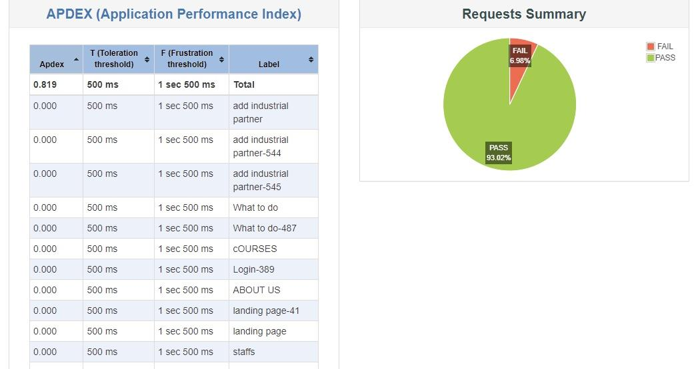



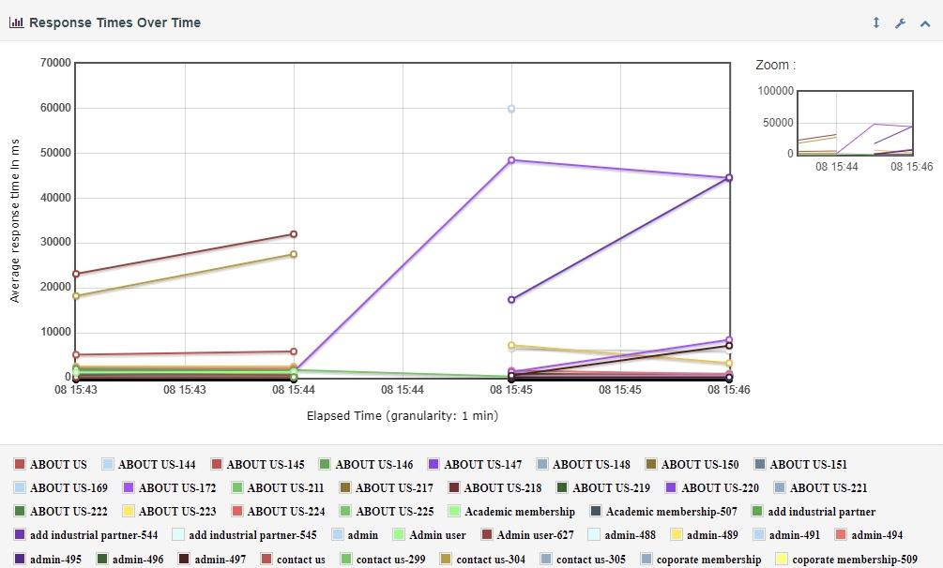

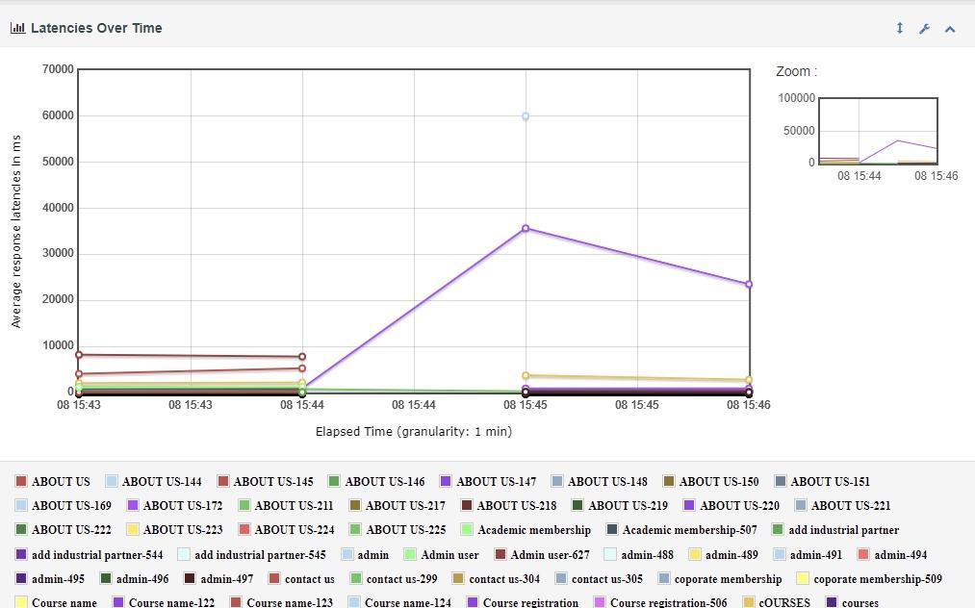

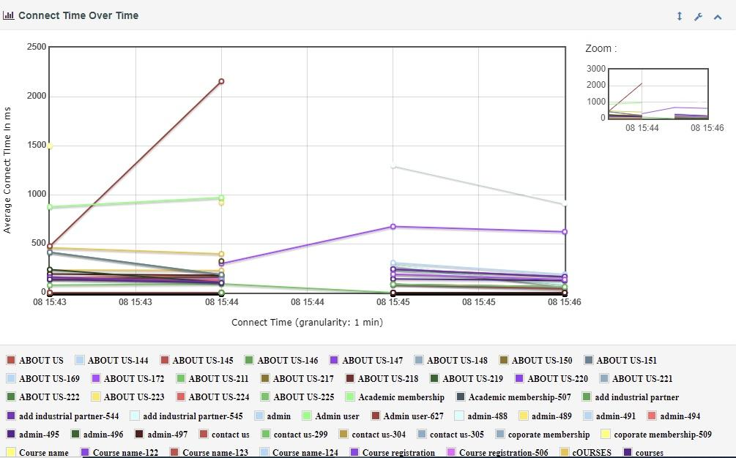

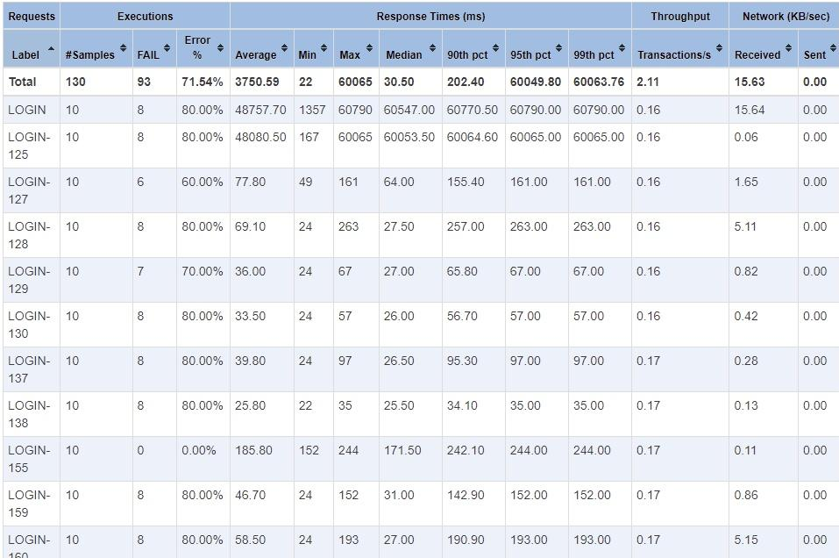

## Performance Test Result Description

### Smoke Test

The smoke test was designed to ensure that the performance test scripts should work properly in the Performance Test Environment. The smoke test was executed with 10 users load for 15 minutes and no issue was identified pre, during and post periods. Also, the Performance Monitors that were configured for metrics collection, were operating as expected.

## Performance Test Overall summary

ICT website performance testing 93.02% pass and 6.98%fail

Login module 98%passed

The JMeter performance report **summarizes the validity of the run**, shows the average sample response time for the requests in the test, and graphs the sample response time of each sample for a specified interval. Overall page

**Table 13: Performance Test Environment Details**

| **Network** | **Environment Tier** | **Hardware Version** | **OS** | **Memory (GB)** | **CPU count** | **Total Disk Space** |
| --- | --- | --- | --- | --- | --- | --- |
| KeralaVision Broadband Wifi | Web Service | Version 10.0.19044 Build 19044 | Windows 10 | 64 GB | 8 cores | 512 GB |
| KeralaVision Broadband Wifi | Web Service | Version 10.0.19044 Build 19044 | Windows 11 | 64 GB | 8 cores | 512 GB |
| jio | Middleware | M620 | Linux | 64 GB | 8 cores | 512 GB |
| jio | Middleware | M620 | Linux | 32 GB | 8 cores | 512 GB |
| Jio | Middleware | M820 | Linux | 32 GB | 16 cores | 1 TB |

## 6. Assumptions, Constraints, Risks and Dependencies

## Assumptions

| **No.** | **Assumption** |
| --- | --- |
| 1 | Since the performance test environment is 50% scaled down of the production environment, so 50% scaled-down load (of production) was considered in the tests. |
| 2 | After the test The team understand the performance of the problems and failures |
| 3 | Jmeter is so easy to apply performance testing and generate html report |
| 4 | The HTML report give a detail explanation in various load apply |

### 

### Constraints

**Constraints**

| **No.** | **Constraint** | **Impact** |
| --- | --- | --- |
| 1 | The Performance Test environment has 50% of the servers that Production has. | The scaling factor of the Performance Test to Production is 50%. All Production Load Models that were executed in the Performance Test environment was at 50% of the full Production load Model to represent a 100% Load. |
| 2 | The Performance Test environment had older data that Production had, which caused an error for some of the data scenarios. | The data in Production had not been purged since 2000; searches in Production intermingle with older data than Performance Test can. This lead the error reported during the test which was not considered in the result analysis. |

### 

### Risks

**Risks**

| **No.** | **Risk** | **Impact** | **Action/Mitigation** | **Assigned To** |
| --- | --- | --- | --- | --- |
| 1 | A large number of errors were detected in the stress test which is marked as Amber (RAG Status) | HIGH | The dev team will continue the investigation and include the resolution in next release. | Development Team |

### 

### 

### Dependencies

**Risks**

| **No.** | **Dependencies** | **Impact** | **Action/Mitigation** | **Assigned To** |
| --- | --- | --- | --- | --- |
| 1 | Extrapolation test result has not been received from the IT team | HIGH | Awaiting the extrapolation result. The performance test report will not be signed-off without extrapolation report. | IT Team |

# Point of Contact

### Test Organization

**Test Organization**

| **Name** | **Functional Role** | **Responsibilities** |
| --- | --- | --- |
| KKEMJL2022_GROUP01 | Project Manager | Facilitating and coordinating all schedules related to SDLC phases and infrastructure |
| Performance Engineering Lead | Manages schedules and activities related to Performance Testing projects |
| Performance Engineer | Prepares for performance test execution, executes performance tests, analyzes performance tests, and tracks problem reports |
| Performance Engineer | Prepares for performance test execution, executes performance tests, analyzes performance tests, and tracks problem reports. |
| Monitoring Support | Monitors performance tests using Performance monitors |
| Application Support | Supports performance test execution as configuration or application issues are found |
| Performance Test Environment Support | Supports and maintains the Performance Test environment |

**7. Referenced Documents**

**Table 22: Referenced Documents**

| **Document Name** | **Document Location and/or URL** | **Issuance Date** |
| --- | --- | --- |
| Apache JMeter Masterclass  By Raghav Pal | <https://www.youtube.com/watch?v=SoW2pBak1_Q> | 29/12/2022 |
|  |  |  |
| JMeter: Performance and Load Testing By, Michael Smith | <https://www.linkedin.com/learning/jmeter-performance-and-load-testing/adding-a-sampler?autoplay=true&u=78898396> | 08/12/2022 |
|  |  |  |
| JMeter Load Testing Tutorial By, Edureka | <https://www.youtube.com/watch?v=mXGcBvWYl-U> | 08/12/2022 |